Ring Topology

What Is Ring Topology?
# Source: AI Source: Provided by: [Data Path: Persons Table -> ID Column: 1, Name_En Column: Motasem Essam] -> From: [ChatGPT] on [12/18/2025]
A Ring topology is a network layout where each device is connected to exactly two other devices, forming a circular path for data to travel.

🧠 Simple Definition:
# Source: AI Source: Provided by: [Data Path: Persons Table -> ID Column: 1, Name_En Column: Motasem Essam] -> From: [ChatGPT] on [12/18/2025]
In a ring topology, devices are connected in a loop, and data flows in one direction (or sometimes both), passing through each device until it reaches its destination.

🔁 Visual Representation:
# Source: AI Source: Provided by: [Data Path: Persons Table -> ID Column: 1, Name_En Column: Motasem Essam] -> From: [ChatGPT] on [12/18/2025]
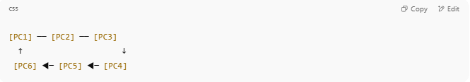
[PC1] ── [PC2] ── [PC3]
↑ ↓
[PC6] ◀─ [PC5] ◀─ [PC4]

Each device forwards data to the next, like a relay race.

⚙️ How It Works
# Source: AI Source: Provided by: [Data Path: Persons Table -> ID Column: 1, Name_En Column: Motasem Essam] -> From: [ChatGPT] on [12/18/2025]
- Data travels one hop at a time around the ring.
- Each device examines incoming data:
  - If it's addressed to itself, it processes it.
  - If not, it passes it on.
- Some ring networks use a token (a special control packet) to manage which device can send data (e.g., Token Ring protocol).

✅ Advantages
# Source: AI Source: Provided by: [Data Path: Persons Table -> ID Column: 1, Name_En Column: Motasem Essam] -> From: [ChatGPT] on [12/18/2025]
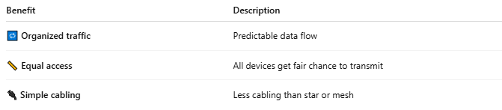

Benefit | Description
🔁 Organized traffic | Predictable data flow
📏 Equal access | All devices get fair chance to transmit
🔌 Simple cabling | Less cabling than star or mesh

❌ Disadvantages
# Source: AI Source: Provided by: [Data Path: Persons Table -> ID Column: 1, Name_En Column: Motasem Essam] -> From: [ChatGPT] on [12/18/2025]
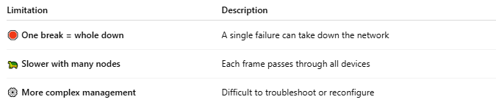

Limitation | Description
🛑 One break = whole down | A single failure can take down the network
🐢 Slower with many nodes | Each frame passes through all devices
⚙️ More complex management | Difficult to troubleshoot or reconfigure

📍 Use Cases (Legacy or Special)
# Source: AI Source: Provided by: [Data Path: Persons Table -> ID Column: 1, Name_En Column: Motasem Essam] -> From: [ChatGPT] on [12/18/2025]
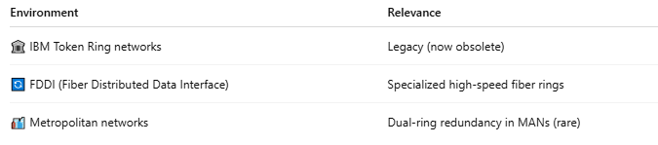

Environment | Relevance
🏛️ IBM Token Ring networks | Legacy (now obsolete)
🔄 FDDI (Fiber Distributed Data Interface) | Specialized high-speed fiber rings
🏙️ Metropolitan networks | Dual-ring redundancy in MANs (rare)

🧾 Comparison: Ring vs Star
# Source: AI Source: Provided by: [Data Path: Persons Table -> ID Column: 1, Name_En Column: Motasem Essam] -> From: [ChatGPT] on [12/18/2025]
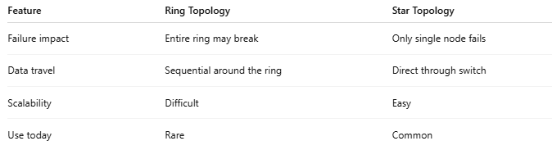

Feature | Ring Topology | Star Topology
Failure impact | Entire ring may break | Only single node fails
Data travel | Sequential around the ring | Direct through switch
Scalability | Difficult | Easy
Use today | Rare | Common

✅ Summary
# Source: AI Source: Provided by: [Data Path: Persons Table -> ID Column: 1, Name_En Column: Motasem Essam] -> From: [ChatGPT] on [12/18/2025]
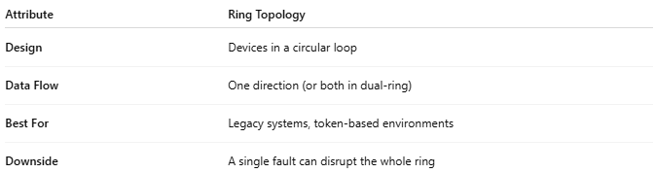

Attribute | Ring Topology
Design | Devices in a circular loop
Data Flow | One direction (or both in dual-ring)
Best For | Legacy systems, token-based environments
Downside | A single fault can disrupt the whole ring

